FINAL REPORT OF LIVING LAB PROJECT

I. Introduction:
Teacher: TONG THI THANH HUONG
Type: Extra-Curriculum Activities
School: Tuyen Quang High School For The Gifted
Grade: 10th
Number of Students: 34
Number of Groups: 3
Semester Starts on: September 9th
Semester Ends on: December 30th
Duration of Living Lab Project: September 9th ~ December 30th
Title of the Living Lab Project: Using recycled materials to create a play area for disabled children at Huong Sen Rehabilitation Hospital in Tuyên Quang
II. Project Summary:
1. What is the Problem?
- Waste is an urgent issue that needs to be dealt with to minimize negative impacts on the environment.
- Huong Sen Rehabilitation Hospital has just moved to a new location and lacks play areas for children.
- The whole community needs to pay special attention to children, especially children with disabilities.
2. What are the attempted solutions?
Our project solutions aim to solve the above two problems: environmental issues and supporting Huong Sen Hospital.
- The primary goal of this project is to engage students to use recycled materials to create a play area for disabled children at Huong Sen Rehabilitation Hospital in Tuyên Quang.
- This project also aims at developing students’ initiatives that contribute positively to our community and fostering a sense of responsibility and citizenship.
3. How was the project implemented? (who did what and how?)
First of all, the teacher met with the director of Huong Sen hospital to ask for permission to carry out the project. Then, the teacher and students went to the hospital to work with the doctors, nurses, and the hospital's youth union to discuss the project proposals. After the discussion, each group agreed on the project solutions and then they designed their products themselves and implemented the projects as follows.

 | Group 1 | Group 2 | Group 3
Project title | Tire Bridges to Adventure: Creating Outdoor Fun for Children | Upcycling Tires: Creating a Flower Yard for Children's Joy | Tires for Smiles: Crafting a Playground for Disabled Children
What they did | Making a playground with bridges made from old tires for children's outdoor adventures | Creating a relaxing flower yard by planting flowers in old tires planters | Creating a safe space for children by transforming old tires into chairs

The project was carried out in 3 phases: (1) Planning and Project selection, (2) Living lab project Implementation, (3) Project Evaluation and Finalization. The class was divided into 3 groups with a group leader each. Teacher provided students with dedicated support throughout the project such as funding, IT skills, problem solving, etc.

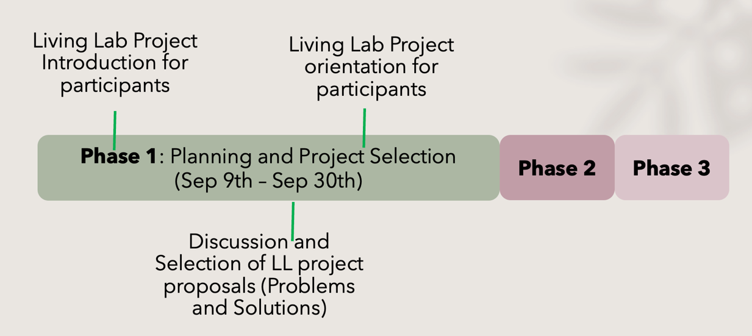

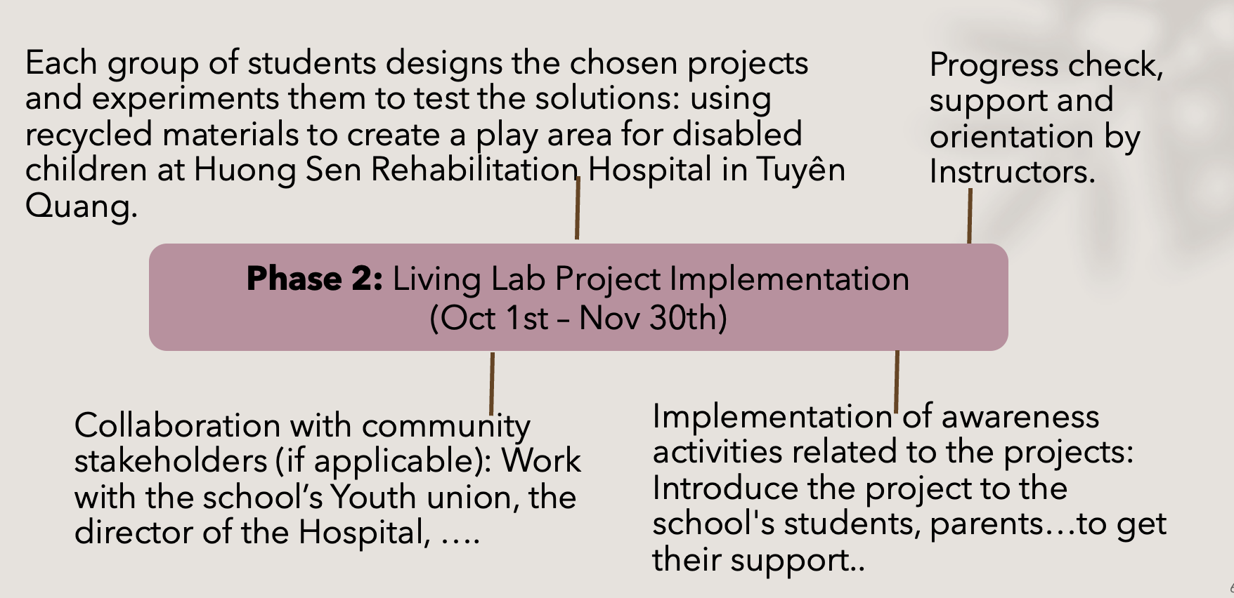

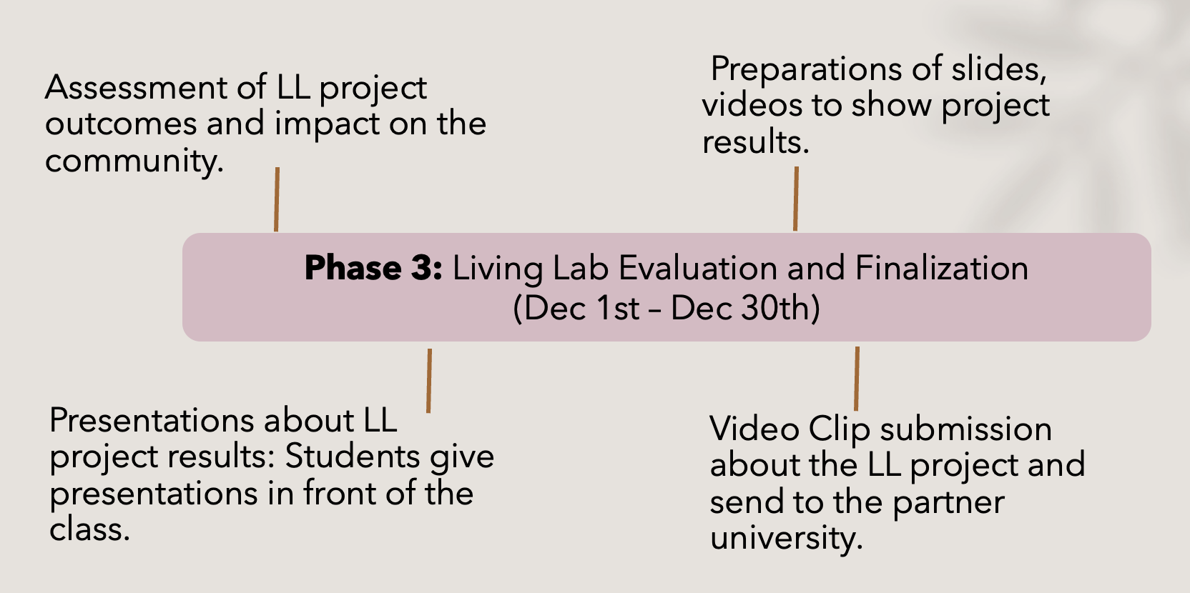
4. What are the outcomes?
- By recycling and repurposing unused objects or trash, students created a creative play area for disabled children and improved the environment at Huong Sen Rehabilitation Hospital in Tuyen Quang.
- The project helped increase students’ awareness and engagement in community issues.
III. Implications
1. Is this project helpful for your students somehow?
The completion of the project has brought many benefits to the children at the hospital as well as the participating students.
- Having participated in the project, students were not only involved in meaningful extracurricular activities that helped them stay away from excessive phone use but also raised environmental awareness and a sense of community.
- Students also developed valuable necessary life skills such as teamwork skills, time management, information technology skills, presentation skills, and problem solving skills.

2. Is there any limitation or downside of this project?
- Skill Gaps: Projects required some skills that students haven’t yet developed, such as, information technology skills, skills in using mechanical tools and equipment .
- Difficult management: Products that are not firmly attached to the ground can be carried around by children after a period of use.
3. Do you have any suggestions for improvement?
- Future projects can be done on a larger scale with more classes of students involved.
- Encourage students to create more diverse and larger solutions.

