FINAL REPORT OF LIVING LAB PROJECT
Teacher | PHAM THI HONG NHUNG
Type | Extra-Curriculum Activities
School | Thai Hoa High School
Grade | 10th
Number of Students | 48
Number of Groups | 4
Semester Starts on | September 6th
Semester Ends on | December 30th
Duration of Living Lab Project | September 6th ~ December 30th
Title of the Living Lab Project | Changing the habit of using smartphones indiscriminately and inappropriately among secondary school students.
Project Summary | What is the Problem?  In today's digital era, the pervasive use of mobile phones among students has emerged as a significant concern. This reliance on mobile devices not only detracts from academic performance but also introduces numerous health and social challenges. Among the adverse effects are diminished concentration during classes, increased incidences of procrastination and sleep disturbances, as well as a reduction in meaningful face-to-face interactions with peers and family members. Hence, the effective management and responsible usage of mobile phones within educational settings represent a crucial issue that demands our comprehensive attention and strategic intervention.  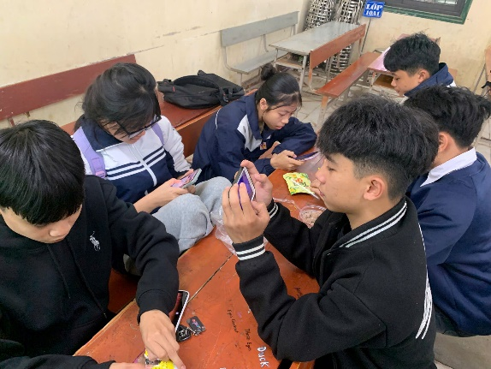  What are the attempted solutions?  They devised a solution to mitigate the effects of “Nomophobia” on today's youth, aiming to foster healthier phone habits and overall well-being, ensuring they can fully enjoy the benefits of technology without adverse impacts.  During our experiment, they encouraged participants to discover the joy of outdoor games, traditional folk games, and brain-teasing activities. Through a series of engaging sessions, they highlighted the numerous benefits and sheer fun that come from stepping away from phones and immersing themselves in phone-free games.  Imagine flying kites in lush green fields, or playing traditional folk games like hopscotch, jump rope, or marbles with friends. These activities not only help reconnect with nature but also improve cognitive skills, boost physical health, and provide invaluable joyful experiences.  The sessions clearly demonstrated the significant difference between sitting passively in front of a phone screen and actively engaging in outdoor activities. Participants were seen laughing, moving around, and genuinely enjoying the memorable moments these games offered.  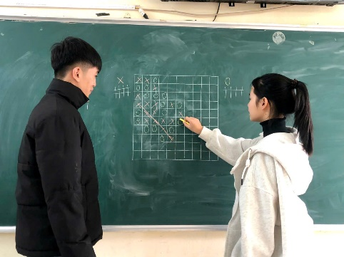  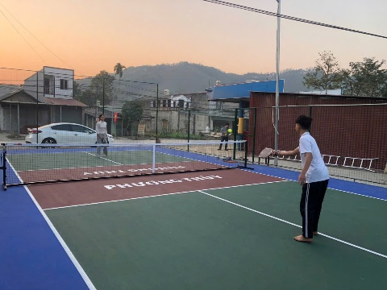  How was the project implemented? (who did what and how?)  Here's a detailed overview of how tasks were divided among team members:  1. Surveys of Target Groups:  - Pham Anh Quan, Nguyen Manh Truong, Vu Diem Quynh, and Dang Quoc Viet were responsible for conducting surveys. Their primary task was to engage with the target groups identified for the project, collect relevant data, and ensure accurate and comprehensive survey results.  2. Image Collection:  - Pham Thuy Diep, Hoang Linh Giang, Tran Mai Duyen, Quach Hoang Duong, and Vu Quoc Dat took charge of collecting real-life images. Their responsibility was to capture images that would be pertinent to the project's objectives and could be used to visually support our findings.  3. Slide Presentation:  - Vu Quynh Anh, Hoang Phuong Thuy, and Nguyen Viet Kien were tasked with creating the slide presentation. Their role involved organizing the collected data and images into a cohesive and visually appealing presentation that effectively communicated our project's progress and findings.  4. Content Review and Censorship:  - Bui Quang Phuc (team leader) oversaw the entire content creation process. His duties included reviewing and censoring content to ensure that all information presented was accurate, clear, and aligned with the project's goals.  What are the outcomes?  The experiment was completed, the presenters realized that the rate of using the phone for more than 8 hours a day has decreased significantly and the rate of people using the phone from 1-5 hours has increased slightly.  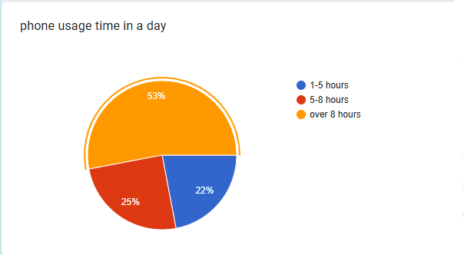  Data before experiment  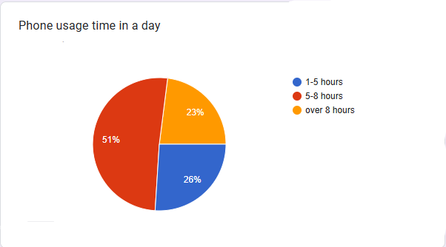  Data after experiment
Implications | Is this project helpful for your students somehow?  Enhance skill development: Research Skills, Presentation Skills,  Teamwork and leadership.  Improve awareness of smartphone habits: By conducting surveys and analyzing data, students gained a deeper understanding of the effects of excessive phone usage. They learned about the importance of balance between technology and real-life activities, which could positively influence their own habits.  Is there any limitation or downside of this project?  Limited Long-Term Impact: Students may revert to excessive phone use after the project ends, as habits are hard to change permanently without sustained efforts or follow-ups. Group 4 members may face the challenge of maintaining the interest of attendees in participating the different outdoor activities.  Reliance on Personal Willpower: Changing phone habits requires significant personal motivation, which might not be sustainable for all participants. Some students might not fully commit to reducing their screen time despite being part of the project.  Resistance to Change: Some students may not find outdoor games or traditional activities engaging or relevant in today’s digital era, leading to low participation or enthusiasm.  Do you have any suggestions for improvement?  Long-Term Engagement Strategies: Organize regular follow-ups or check-ins with participants to reinforce the lessons and monitor progress in reducing smartphone use. Encourage other students to set measurable goals (e.g., reducing screen time by 30 minutes each week) and celebrate milestones to sustain motivation.  School Policy: Collaborate with school administrators to establish policies promoting limited smartphone use during school hours, like "phone-free zones" or specific times for tech use.  Diversify activities: Introduce a mix of traditional games and modern activities (e.g., board games, creative workshops) to cater to students who might not relate to folk games. Include workshops on coding, arts, or music to show students alternative productive uses of their time, keep them away from mobile phone.

