FINAL REPORT OF LIVING LAB PROJECT
Teacher | PHAM THI HONG NHUNG
Type | Extra-Curriculum Activities
School | Thai Hoa High School
Grade | 10th
Number of Students | 48
Number of Groups | 4
Semester Starts on | September 6th
Semester Ends on | December 30th
Duration of Living Lab Project | September 6th ~ December 30th
Title of the Living Lab Project | Processing plastic waste on the school campus.
Project Summary | What is the Problem?  They find out that one of the biggest problems on the school campus is the amount of plastic waste from the cafeteria and the amount of trash that students bring to class. This means, when students eat and drink in the canteen, you do not throw trash there but bring it back to class. Every day, they throw away a lot of plastic bread covers, milk cartons and water bottles. This not only pollutes the environment but also wastes resources. We all know that plastic waste takes a long time to decompose. Normally, a plastic bottle, straw or plastic bag if thrown into a landfill can take hundreds of years to completely decompose. Currently, the harmful effects of plastic waste on our lives are huge. Therefore, Group 2 decided to make recyclable items from plastic waste instead of throwing or burning them.  What are the attempted solutions?  A solution to minimize the harmful effects of plastic waste is to recycle plastic waste into objects that help people work and decorate their homes/workplaces/classrooms. Their discussion aims to propagate and suggest ways to properly handle plastic waste, contributing to making the environment greener, cleaner and more beautiful.  How was the project implemented? (who did what and how?)  The project implemented: First, in October, when the project started, they spent 20 days carefully choosing the problem. They then spent some time finding solutions and discussing the chosen problem specifically.  Starting on 1st November, their team focused on carrying out plastic waste recycling processes. Here is the summary of different steps on how to assign tasks among team members:  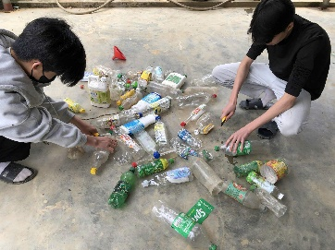  Step 1: Collect trash  Members: Tran Thai Duong, Chu The Ngoc  Tasks: Collect plastic waste from schools, specifically in the canteen and school yard.  Step 2: Sort trash  Members: Hoang Tuan Phong  Task: Find and classify bottles, jars, etc. of the same shape and color suitable for making products.  Step 3: Waste treatment  Members: Truong Tri Trung  Mission: Cleaning trash and make them ready to be recyled.  Step 4: Create products  Members: Nguyen Hoang Vu, Ngo Gia Bao, Luong Hong Vi.  Task: Create products: make brooms, dustpans, pen boxes and flower vases.  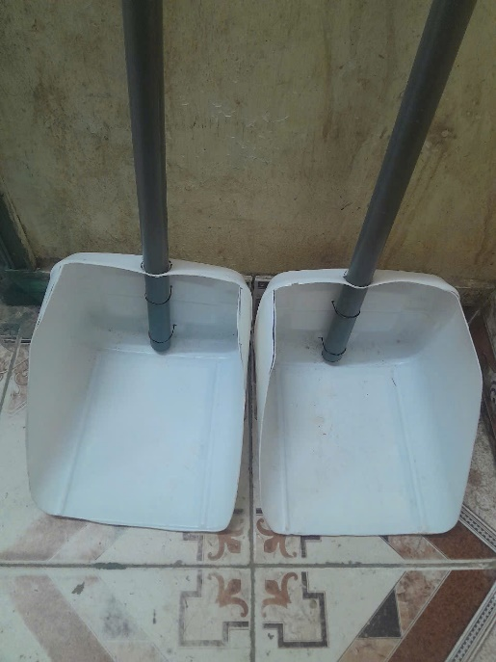  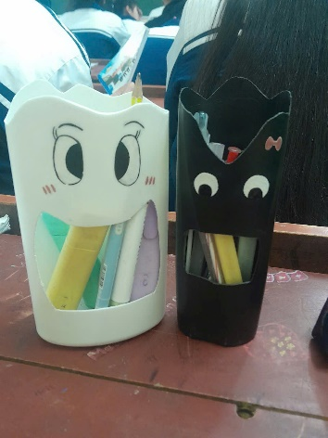  Step 5: Do a survey and make a observation  Members: Nguyen Ngoc Anh, Dinh Phuong Anh  Task: Observe the changes after working out this project.  What are the outcomes?  Reduction in Plastic Waste: A significant amount of plastic waste from the school campus, including bread covers, milk cartons, and water bottles, was collected and recycled. At Canteen, the school yard and in the classroom, there is a change in the treatment and recycling of garbage, creating an increasingly friendly environment.  Creation of Useful Products  The team successfully transformed plastic waste into practical and decorative items. These products not only showcased the creative reuse of materials but also served functional purposes in classrooms and homes.  Enhance Environmental Awareness: The project raised awareness among students and staff about the importance of recycling and proper waste management.  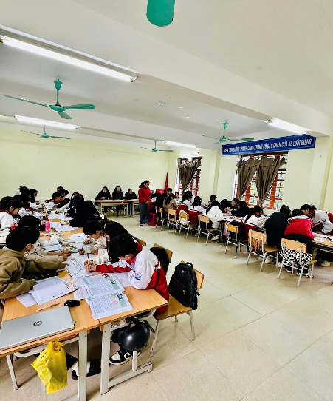  The classroom is clean without plastic waste  Positive Behavioral Changes: Students began to handle plastic waste more responsibly, with reduced littering observed in the canteen, classrooms, and schoolyard.  Community Engagement: The initiative attracted attention from the school community, inspiring others to participate in or replicate similar projects. Teachers, students, and parents became more involved in environmental activities.
Implications | Is this project helpful for your students somehow?  Environmental Awareness:  The project teaches students about the harmful effects of plastic waste and the importance of recycling. It helps them understand the environmental consequences of their actions, raise awareness of protecting the environment.  Hands-on Learning:  Students actively participate in collecting, sorting, and recycling plastic waste, giving them practical experience in waste management and problem-solving.  Creativity and Innovation:  By turning plastic waste into useful and decorative items like brooms, pen boxes, and flower vases, students develop their creativity and learn to think innovatively about repurposing materials.  Teamwork and Collaboration:  The project involves dividing tasks among team members, which teaches students the value of teamwork, organization, and effective communication to achieve a common goal.  Is there any limitation or downside of this project?  Time Constraints  Students may have limited time to dedicate to the project due to academic responsibilities, exams, or extracurricular activities, which could affect progress. Some tasks, such as cleaning and crafting, can be time-intensive and may lead to delays in producing results.  Quality and Usefulness of Products  The recycled products, while innovative, may not always be of high quality or practical use. For example, items like brooms and flower vases may not meet durability or aesthetic expectations, limiting their appeal. There’s also a risk that other people might not fully value or use these items, leading to minimal impact.  Do you have any suggestions for improvement?  Educate on Waste Reduction: Include a campaign to teach students how to reduce plastic consumption in the first place (e.g., bringing reusable water bottles, lunch boxes, or eco-friendly packaging).  Ban Single-Use Plastics on Campus: Advocate for a school-wide policy to replace single-use plastics with sustainable alternatives in the cafeteria (e.g., paper straws, bamboo cutlery).  Expand the Product Range: Create items that have greater everyday utility, such as pencil holders, storage bins, lanterns, nameplates, bookmarks or artwork, which can be sold to raise funds.  Increase Awareness and Participation: Set up peer-led presentations or competitions to educate students about the environmental impact of plastic and recycling. Organize an annual “Green Fair” where students showcase and sell recycled products, with proceeds going to environmental initiatives.

