FINAL REPORT OF LIVING LAB PROJECT

Teacher | PHAM THI HONG NHUNG
Type | Extra-Curriculum Activities
School | Thai Hoa High School
Grade | 10th
Number of Students | 48
Number of Groups | 4
Semester Starts on | September 6th
Semester Ends on | December 30th
Duration of Living Lab Project | September 6th ~ December 30th
Title of the Living Lab Project | Igniting a passion for English at Thai Hoa High school
Project Summary | What is the Problem?  Currently, when the our country is gradually integrating with the world, learning foreign languages is extremely important in personal development to promote social development. Our native language has a very different structure and pronunciation from English, this makes the process of learning English more difficult than ever, so English for students of Thai Hoa high school is considered a "nightmare", they tend to avoid it, and even suffer from "foreign language phobia", Group 2, English explorers, have come up with solutions to minimize the fear of foreign languages in the school environment and lead the students of Thai Hoa High School to awaken their passion for English.  What are the attempted solutions?  To solve the above problems they have implemented solutions called 4E:  ● 1E: English signage and announcements  ● 2E: English learning corner  ● 3E: English club  ● 4E: English learning through apps and game  How was the project implemented? (who did what and how?)  +1E: English signage and announcements  - In this first solution, their team together came up with the idea of using lively and interesting drawings to draw signs around the school to attract people around to see and make them curious about the school. The meaning of the word or students can add words that team members chose to their vocabulary. In addition, they proposed this solution with the hope that it would bring a feeling of closeness between English and students, help them feel more comfortable when exposed to English, reduce the difficulty and worry about using English every day.    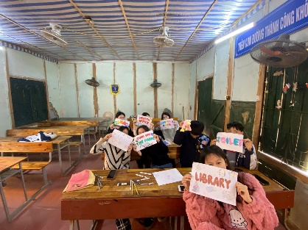  + 2E: English learning corner  The second solution, to motivate students to write more, with the consent of the School Union, for 1 month they used the school's information board as a small corner called "USE OF ENGLISH" in the corner of this board, school students only used English to express their wishes and desires for the upcoming new year.  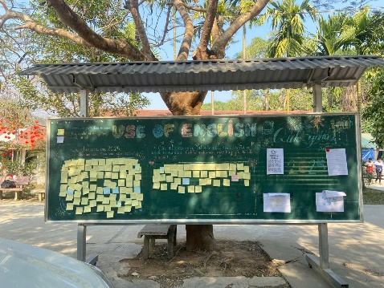  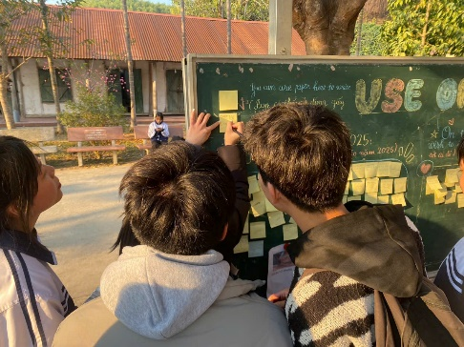  + 3E: English club  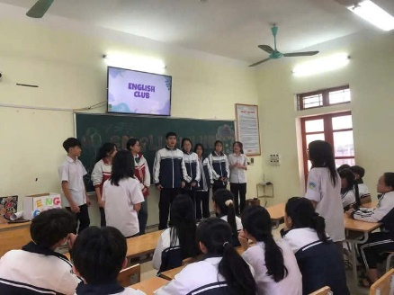  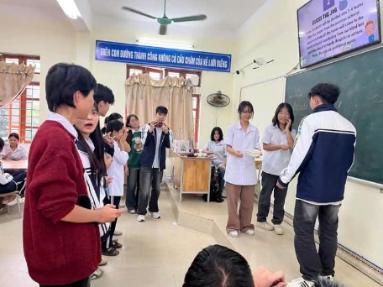  The third solution, with the desire to turn English into a game or an afterschool activity, they coordinated with the school's English teachers to establish an English club. After establishment, they called on participants to build a club, then gradually organize themed activities, according to each period of the year, for example: Christmas-themed club activities, birthdays, programs about Tet,.... They searched together to understand and created countless interesting games that both provided knowledge and created an entertainment space for everyone.  + 4E: English learning through apps and games  The final solution is to urge everyone to learn English using apps or participate in playing games on the internet. Realizing that nowadays almost all students in school like to use social media. When Memorizing countless difficult vocabulary or grammar on blank paper will create a feeling of boredom. Sometimes you will feel stressed because you can't remember it after studying forever, so we recommend learning English through some apps such as Duolingo, Kahoot,.... This will be more accessible to students in the current trend of technology, moreover, when using the above applications, they will also experience learning English as if they are on an adventure in a certain game, and sometimes when they will receive exciting rewards  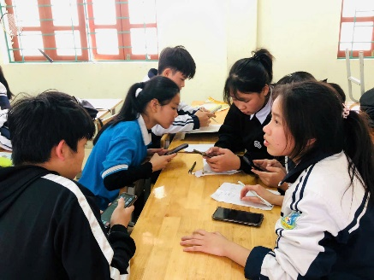  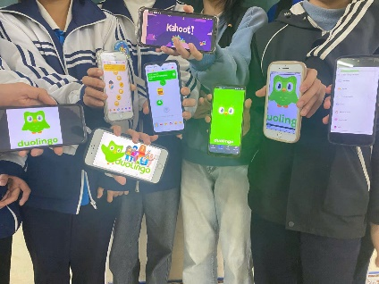  What are the outcomes?  After adopting these solutions, the presenters received many positive responses from students across the school, especially students in grade 10:  - Their final exam scores increased significantly after 3 months from the beginning of the project.  - Their interest in English has increased  - Most have improved their confidence when communicating using English with others
Implications | Is this project helpful for your students somehow?  Enhance language skills and confidence.  By creating English signage, running an English corner, and leading club activities, students actively practice vocabulary, grammar, and communication skills in real-life contexts. Organizing events and interacting with peers in English boosts their confidence in speaking and using the language.  Leadership Development: Students take on leadership roles to plan and execute the project, gaining experience in managing tasks, coordinating activities, and leading teams. It also fosters teamwork and problem-solving abilities.  Organizational and Project Management Skills: Students learn to allocate responsibilities effectively, set timelines, and manage resources efficiently. It teaches them how to plan and execute educational events.  Is there any limitation or downside of this project?  Resource and Time Constraints  Designing and implementing solutions like signage, English corners, or club events requires materials, time, and effort, which might be challenging to sustain in the long term.  Dependence on Technology: The solution involving apps and games assumes that students have access to smartphones, tablets, or the internet, which may not be the case for everyone. Also, excessive use of apps and games could distract students from other important learning activities or reduce face-to-face interaction.  Sustainability Challenges: Maintaining long-term interest in the project might be difficult, especially when students are busy with their examinations or if the activities become repetitive. Without proper follow-up, students might revert to their old habits of avoiding English outside of project activities.  Do you have any suggestions for improvement?  Diversify Activities to Engage All Students  Not all students learn the same way, so incorporating a wider variety of activities can help engage more participants. Introduce role-playing, debates, or storytelling competitions to make learning English more interactive.  Offer Incentives and Rewards  Recognizing student efforts can motivate participation. Create a reward system with certificates, badges, or small prizes for students who achieve specific goals (e.g., most vocabulary learned in a month). This builds a sense of achievement and encourages consistent effort.  Peer-to-Peer Learning  Students often feel more comfortable learning from their peers. Pair proficient English speakers with struggling learners in a “buddy system.” This fosters collaboration and helps students improve in a non-intimidating environment.

