Living Lab Group Activities

University/  Group no. | Subject | Background | Problems | Experiments for Solutions | Expectations  (before and after) | Significance  (Social, economic, or educational) | Current stage | etc.
Yonsei Uni.  /  Group 1 | Tracking the movements of elderly people picking up waste paper | In South Korea, there are people (mostly elderly) who make money by picking up and selling waste papers on the road.  They are elderly people with extreme poverty and picking up wastes is very helpful for them to live. They pick them up and sell to local waste collection center. In Korea, their role in collecting waste papers takes 40% of the total collection. Therefore, they play a role in circular economy. | There are more than 120 elderly people in Wonju City who live by picking up waste papers.  However, they choose dangerous roads with heavy traffics.  Also, their routes are not only dangerous but also, they do not know the optimal route to minimize their move and maximize the collections. | Attach GPS navigators to seniors to determine if their route is dangerous or not.  Attach action camera to them to identify how much they collect in a given point.  If the route is dangerous and ineffective, we shall find alternative routes which are more effective in terms of moving distance and the amount of collection.  We shall see if these solutions will make them safe and effective. | We expect that we can suggest for 10 elders (the participants of experiments) a safe and effective route for each of them. In other words, we shall provide individual solutions for each participant. It depends on the location of their homes, and the locations of the local collection centers. (There are four collection centers in Wonju. The elderly people must use one of them to sell what they have collected) | Creating a social safety net for elderly with low income.  protecting the vulnerable people by using simple technologies | Collecting information and field work completed.  Experiment plan completed.  Creating a video in progress | 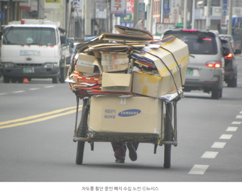  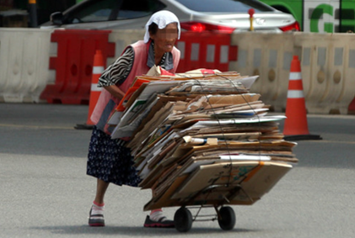  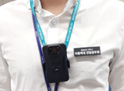
Yonsei Uni.  /  Group 2 | Recycling used military supplies | Items used by soldiers are not recycled and thrown away without question.  The military command has no incentive to recycle the huge amount of used apparels (military uniforms). | There is an army camp stationed in Wonju City, which oversees providing new items to soldiers.  They sell used uniforms to local waste collectors. The amount of wasted military wastes (not only apparels but also gloves, hats, shoes, and others) is huge. | Collecting and recycling fabric from military uniforms. We will use them by warming trees in the wintertime, and making gloves for delivery bike riders, etc. | We shall provide a new example in which a public institution (such as army camp) makes efforts to recycle what they waste. They usually have no incentive to recycle because they can pay to waste them, and the payment is covered by the government. In Korea, there are many large public institutions who do not consider reuse or recycle.  We shall also recommend the government to give the officials to have incentives for reuse and recycling. For example, if they reuse and recycle, they will get some points to be considered for their promotion. | Improving environmental awareness of public institutions. | Collecting information and field work completed.  Experiment plan completed.  Creating a video in progress | 